Results of the Second Health Centre Survey

David I. Levine
Rachel Gardner
Ian Ramage
and Karen Zhang

This briefing paper summarizes a two-wave longitudinal survey of health centres affiliated with the SKY micro-health insurance program in rural Cambodia. The baseline survey describes the status of these health centres in Fall 2008 while the follow-up data are from Fall 2010.
Health insurance for the rural poor
SKY (“Sokapheap Krousat Yeugn,” “Health for Our Families,” in Khmer) is an innovative micro-health insurance program for the rural poor in Cambodia. SKY was created by the Groupe de Recherche et d’Echanges Technologiques (GRET), a French NGO. SKY seeks to improve the health of Cambodians by providing affordable and accessible health insurance and quality care.
For a fixed monthly premium, SKY offers households free and unlimited primary and emergency care at local health centres. One of SKY’s primary goals is to enable families to cover health costs without risking impoverishment. In regions where it operates, SKY typically represents the only health insurance option available. By 2008, SKY operated in four provinces (Takeo, Kandal, Kampong Thom, and Kompot) and in the capital, Phnom Penh.
Expanding Access, improving quality of the public health system
SKY contracts directly with Cambodia’s public health system, which primarily has three levels of facilities: Provincial-level hospitals, smaller Operational District (OD) Referral Hospitals, and community Health Centres, which are the focus of this study.
Each Health Centre serves several villages, around 13,500 people on average. Public facilities suffer from low utilization. According to 2005 Demographic and Health Survey (DHS) estimates, less than a quarter of those who sought treatment for illness or injury, visited a public health facility. Long waiting time, shortage of supplies, and impolite staff were common complaints of the facilities.
One of SKY’s primary goals is to “facilitate and encourage … quality health care, both at primary and secondary levels, to prevent severe health risks.” To further that goal, SKY contracted with the highest quality Health Centres in Cambodia. SKY also makes efforts to improve the quality of health care delivered by these facilities. It hires Member Facilitators to monitor facilities, conduct surveys, and manage client complaints. In addition, prepayment of health services provides some funding for the health centres to buy supplies.

Methods
In fall of 2008, we asked SKY’s 38 Member Facilitators to describe the 38 health centres where they work. These Centres serve the areas where SKY initiated operations from December 2007 through December 2008. The survey asks about health centre quality, and how the facility has changed since SKY began operations. The survey uses a set of checklists on “thank you” payments, operating hours, drug supply, cleanliness, and equipment.
In Fall 2010 we repeated this survey with 42 Member Facilitators.

Results

Perceived Improvements in Service
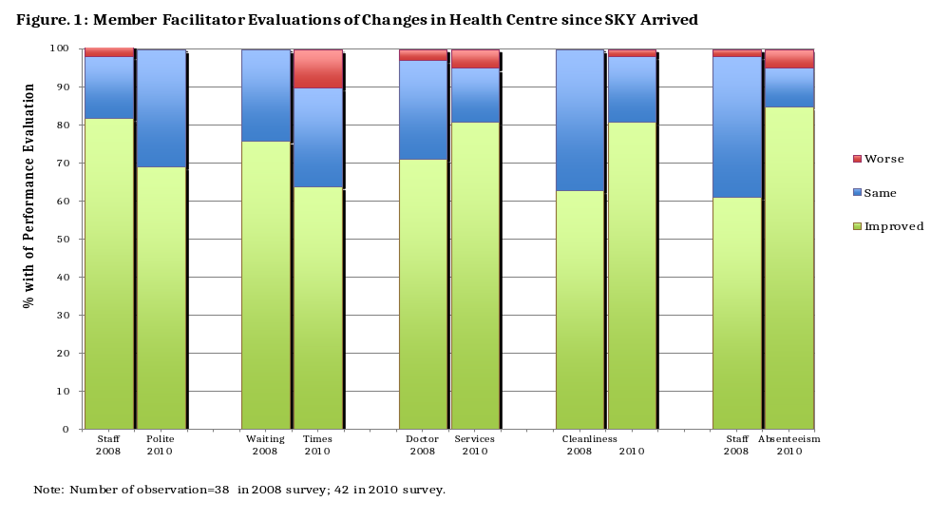In the 2010 survey more than 60% of the 42 member facilitators reported improvements in each of staff politeness, waiting time, doctor services, cleanliness, and staff absenteeism, though only the improvement in absenteeism was large or statistically significant at the 5% level (Fig. 1). Fewer than 10% reported declines in quality on any measure. Only waiting time declined substantively (which was also statistically significant at the 5% level). In general, the encouraging results were similar to those reported in the 2008 survey.

Despite the SKY prohibition of thank-you payments at its centres, two thirds of member facilitators report that clients pay thank-you payments to staffs at least occasionally. Comparing with the first round survey, the second round indicates increased frequency in both “sometimes” and “rarely” thank you payment. One member facilitators in 2010 reported frequent thank you payment are “always” paid, while no member facilitators in 2008 reported payments were “frequent” (the corresponding category in the 2008 survey, Fig. 2).
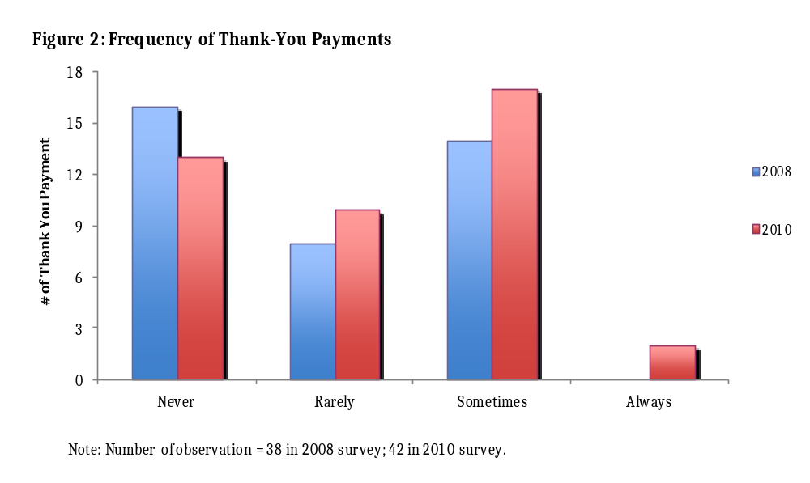
Hours of Operation
Member facilitators report that health centres are open an average of 8½ hours a day on weekdays and 8.1 hours on Saturday (Fig. 3). (The survey did not ask about Sunday.) Both figures are a bit higher than in 2008 (7.4 hours weekdays, 6.9 on Saturdays, with increases on four of the 5 weekdays’ increases statistically significant at the 5% level). The increase in Saturday hours is largely due to an increase from 82 to 95% being open at all. Member facilitators also report an increase in 24-hours stand-by service from around 25% of health centres in 2008 to a third in 2010 (Fig. 4).
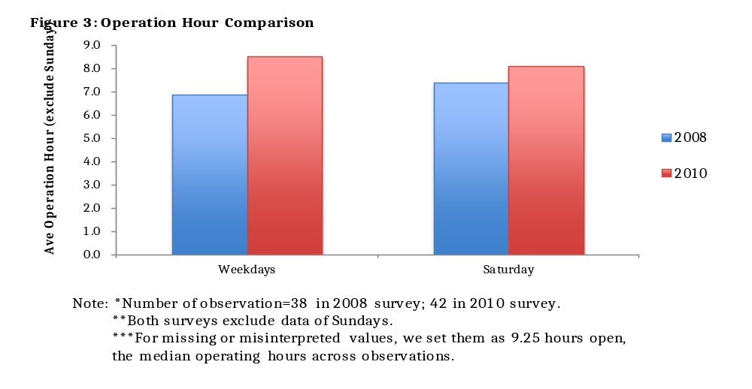
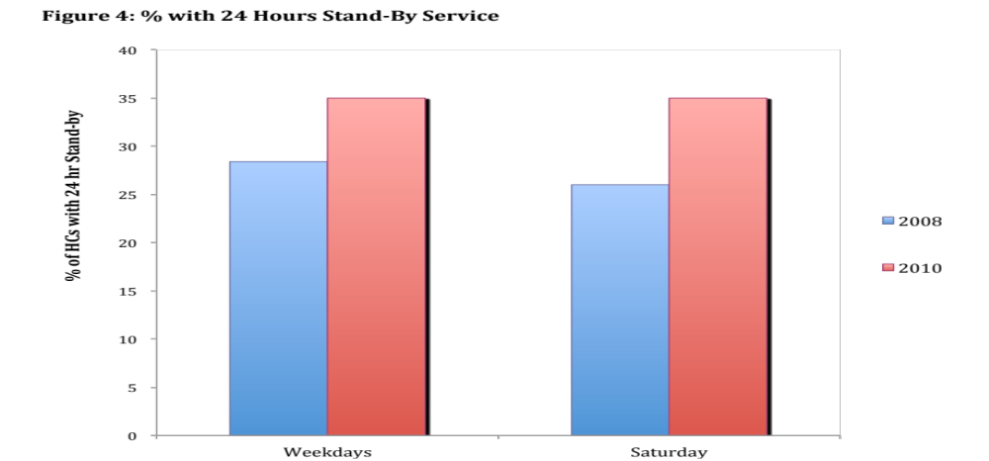
Note: *Number of observation = 38 in 2008 survey; 42 in 2010 survey.
**We consider “24 hours stand-by” the situation that patients can drop off at the health centers and
receive simple treatment after even though most doctors and staffs are off duty. Observations are
considered as providing “24 hours stand-by” if and only if interviewees explicit convey information such
as “the office does not close”, “staffs stand by all the time”, or “they do not close the door of health center
so people can go.” Whereas, people guard the door” are not equivalent to 24 hours stand-by service.

Drugs and Supplies
Member Facilitators checked the availability of 10 types of drugs and 2 different supplies at the Health Centres. The average facility was missing 1.4 of the 12 drugs and supplies, with a range from 0 (for 31% of the health centres) to 3 missing items.
Figure 5 indicates general improvement in medicines and supplies stock since the 2008 survey. 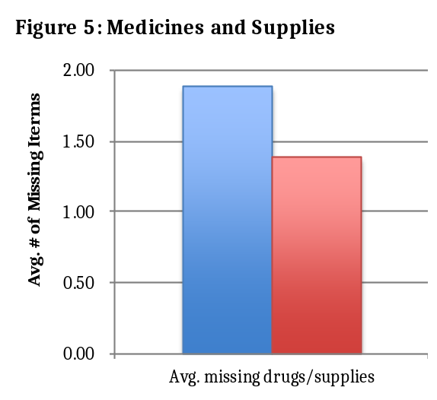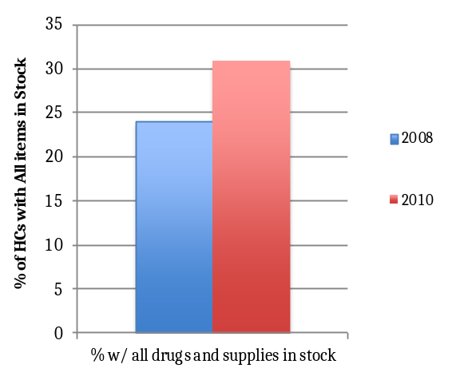
NOTE: *Number of observation= 38 in 2008 survey; 42 in 2010 survey.
**Measures are made out of 12 items: Ferrous sulphate or Fe/Folate, paracetamol 100mg tablets, amoxicillin or ampicillin
250mg, ORS sachets, Combined oral contraceptice (oestrogen and progesterone COC)), progesterone only pill (POP),
aresunate/mefloquine, tetracycline eye ointment (antibiotic not steroid), vitamin A 100,000U, benzyl benzoate 25%, nylon
suture 2/0, and gauze rolls.

The supply of malaria medicine (artesunate/ melfloquine) increased from 32% to 43% (increase statistically significant at the 5% level). However it still remained the most frequently missing supply, absent at two thirds of health centres (Fig. 6). The lack of malaria medicine may be due in part to the fact that malaria is rare in most areas where SKY operates. Nevertheless, infrequent availability is troubling because malaria is endemic in rural Cambodia. 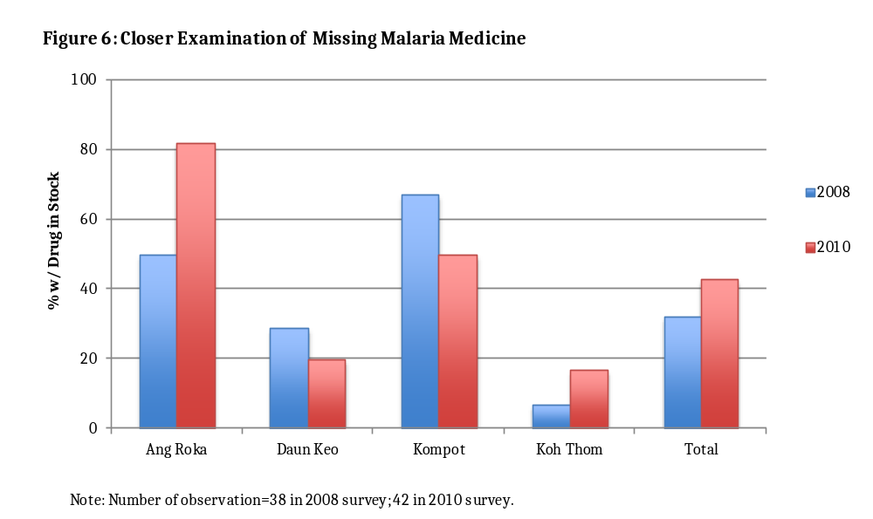

Equipment
Member Facilitators documented whether 8 pieces of equipment (listed in Fig. 7) were available at their health centre.
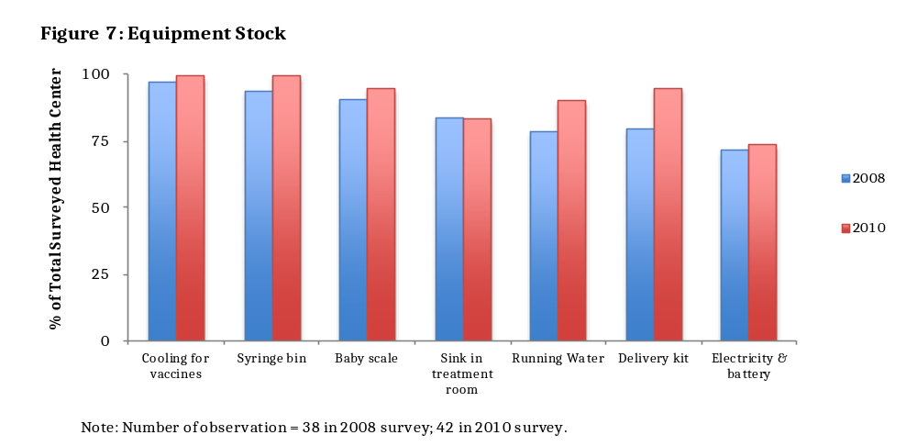In general, health centres have most items on the equipment list, and all items improved since 2008. Electricity back-up devices are the most common missing items (absent in 17% of health centres, an improvement from a 28% absence in 2008). Sinks in treatment rooms is the next most lacking equipment with little improvement. Delivery kit has the largest improvement, increasing from 74% to 95% (increase significant at the 5% level).

Hygiene Problems
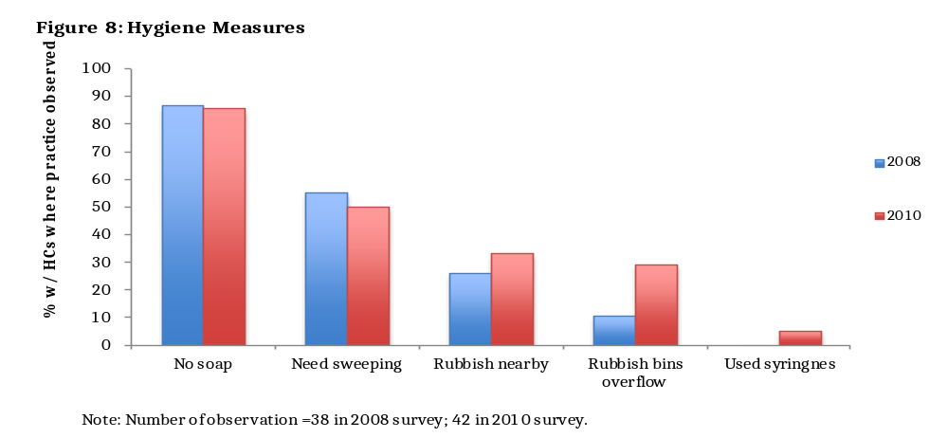The survey measured five dimensions of health centre hygiene: presence of soap and absence of need for sweeping, rubbish nearby, rubbish bins overflowing, and used syringes nearby (Fig. 8). Only one facility is fully hygienic on all five measures, dropping from three facilities reporting no hygiene problems in 2008. Most facilities have at least two unhygienic practices; over 30% have three or four reported problems (increases from 25% as reported in 2008). The most common problems were 86% of facilities lacked soap for the staff (almost the same as the 87% in 2008) and 50% needed the floors swept (similar to the 55% in 2008). Over-flowing rubbish bins was the largest decline in quality (decline significant at the 5% level). Five facilities (almost 20%) have used syringes around the health centres.

Robustness Test

We re-ran the analyses on the 36 health centres that participated in both 2008 survey and 2010. These analyses are robust to changes in the composition of health centres. Results were similar to what we report (Appx. 4).

Conclusions
The results are significantly limited, because the data describe just forty-two health centres based on a single information source. In addition, most of the measures had specific limitations. For example, SKY pays member facilitators to ensure SKY members are treated politely. Thus, the questions on health centre service may be biased by member facilitator wanting to demonstrate they are effective. The responses on health centre hours sometimes conflated hours when staffs were on call versus present. The number of missing drugs and supplies may be sensitive to whether the survey was asked soon after a monthly shipment of supplies arrived, or towards the end of the month.
With those cautions in mind, the results show an improving public health system along most dimensions. Member facilitators in both survey waves believe the quality of service has improved since SKY arrived. Hours of operation typically are as long as official rules and have increased somewhat from 2008 to 2010. Other than the malaria medicine artesunate/ melfloquine most health centres had all or almost all of the 12 drugs and supplies we monitored. There was also an increase in essentially all of the equipment stocks we measured, with universal presence of cooling for vaccines and a syringe bin.
At the same time, quality is inconsistent. Thank you payments, although formally not allowed, are present at most health centres and there is a small increase from 2008 to 2010. Most facilities are missing at least one drug or supply. Perhaps most importantly, staff in nearly all health centres still lack access to the tools needed to provide sterile care such as soap.
It remains unclear the extent to which the improvements in health centre quality we observe are due to the relationship with SKY. We hope to pursue that question with additional qualitative research.

Levine, Gardner and Zhang are from University of California, Berkeley. Ramage is from Domrei Research and Consulting. This working paper was prepared with funding from AFD. We appreciate discussions with Cedric Salze, Dr. Sophat, M. Phoung Pheakdey, Gabriel Pictet, Luize Guimares, Ariella Leaffer and numerous medical professionals at SKY, Cambodian clinics, hospitals and the Ministry of Health.
Answers that reflect positive changes such as “much more polite” and “more polite” are viewed as indications of improvement in corresponding measures, and answers of “less polite” and “much more impolite” as viewed as worsening accordingly. In calculating net improvement, we subtract percentage with HCs that report worsening from percentage with HCs that report improvement.
In analysing operating hours, we distinguished “24 hours stand-by” from “open hours.” We interpret “open hours” as the situation that the majority of doctors and stuffs are on duty and are able to provide full service. On the other hand, we consider “24 hours stand-by” the situation that patients can drop off at the health centers and receive simple treatment even though most doctors and staffs are off duty. We considered an observation as providing “24 hours stand-by” if and only if it has explicit information such as “the office does not close”, “staffs stand by all the time”, and “they do not close the door of health center so people can go.” However, we exclude the case that “people guard the door” from 24 hours stand-by analysis. In order to fairly treat data when interviewees wrongly interpret the term “24 hours stand-by” as “24 hours open”, we set whatever missed value as 9.25 hours open, the medians across other observations. Some observations in the 2008 survey lack information about break time, particularly of health centers that provide 24 hours stand-by service. Given that staffs of those centers usually rotate their breaks, we treat such centres as having no breaks. We used the same adjustments for both the 2008 and 2010 data. Therefore, even though the level of hours may be biased if member facilitators interpreted the questions differently than we intended, if the bias is similar both years then the reported improvement in open hours is probably not due to measurement error.
http://cdc-malaria.ncsa.uiuc.edu/ accessed March 6, 2011
Both surveys also recorded presence of a Manual Vacuum Aspiration Kit. Only one clinic reported a kit in the 2008 survey and none in the 2010 survey. Because this equipment is not standard we excluded it from the analysis.

