**Game Theory and International Climate Change Negotiations**Issue Finding Memo, 29 October 2014  
Patriot Games (Tom Garland, Matt Gunderson, Evan Williams)

**Introduction**

This paper analyses the climate change negotiations that begun in 1992 and continue to shape the future of the environmental impact of major players in the realm of international politics. Our analysis considers the negotiations as a complex web of interdependencies and motives that are informed by such factors as short-term financial costs, long-term economic savings, geopolitical tensions, and domestic political pressures. In order to model and navigate this complexity, this analysis we construct a picture of four scenarios that existed at the international climate change negotiations in the mid-1990s and show that the equilibrium outcome was one that was sub-optimal in that the world would delay action on climate change. We then consider how the parties in the negotiations attempted to change the game by introducing the Clean Development Mechanism (CDM) in the Kyoto Protocol. Finally, we apply game theory again to understand why the Kyoto Protocol broke down, leaving the current situation of the world still grappling to establish a global agreement to limit carbon emissions.

The following graph depicts how we apply the framework for developing a mental model of a game theory interaction to analyze international climate change negotiations.

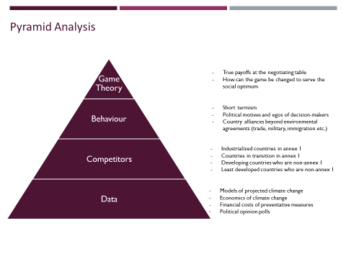

**Background on climate negotiations**

The timeframe we address in this paper is the period from 1992, when 192 countries signed the UN Framework Convention on Climate Change (UNFCCC) at the Earth Summit in Rio De Janeiro through to 2012, when the Kyoto Protocol can be considered to have expired.

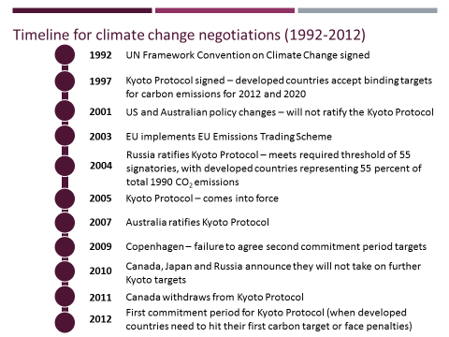

The UNFCCC was a treaty in which countries agreed that they would act to curb greenhouse gas emissions (referred to as carbon emissions throughout the paper) to avoid potentially catastrophic increases in the average temperature across the world (climate change).

Article 4.2 of the UNFCCC commits or industrialized countries to "[take] the lead" in reducing carbon emissions. The initial aim was for industrialized countries to stabilize their emissions at 1990 levels by the year 2000 – this was a statement of intent and had no biding force in international law.

In 1997, the Kyoto Protocol was signed by over 80 countries including all of the industrialized countries who had been party to the UNFCCC. Under the Kyoto Protocol Annex 1 or industrialized countries took on binding targets to cut carbon emissions by 2012. While each country was given a different target, on average the Protocol would lead to industrialized countries reducing carbon emissions by 5% against 1990 levels.

**The players (or competitors)**

The players in this game are the 192 countries that were involved in the UNFCCC and the subsequent climate negotiations in relation to this treaty. As illustrated in the table below these players can be divided into two broad categories – rich countries and poor countries. Rich countries – comprised of industrializes OECD nations and the Economies in Transition of the former USSR – controlled the vast majority of the world’s economic resources and were responsible for the vast majority of the world’s carbon emissions. Poor countries by contrast have a far lower share of global economic output and carbon emissions.

Coming into the climate change negotiations, Economies in Transition had experienced a dramatic disruption in their economies with the fall of the Soviet Union. This meant they had already drastically cut their carbon emissions as much of the outdated manufacturing and power generation facilities of the soviet era were mothballed.

The two groups that were experiencing growing carbon emissions were the industrialized economies of the OECD (US, EU, Japan, Australia, Canada) and developing countries such as China, India, Brazil and Mexico that were experiencing a surge in economic growth.

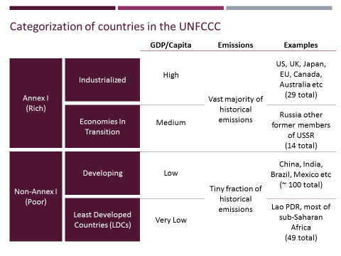

**Analyzing payoffs in climate change negotiations**

**Understanding the social optimum for the world**

The consensus that developed around the need to act on climate change was based on two factors:

1. The long-term costs of climate change were potentially massive – changing climate could flood many of the world’s major population centers, strand infrastructure (e.g. empty dams) and cause global famine due to shifting weather patterns over currently arable land. If left unchecked, climate change would drastically reduce the economic outcomes of the world
2. The short term costs of avoiding climate change were very small – by acting early and in a coordinated fashion to embrace clean technology and invest in clean R&D and infrastructure, countries could head off much of the forecast climate change for a relatively small cost. This has been supported by numerous studies since the agreement, most notably the Stern Review who predicted that the cost of avoiding climate change could be under 1.5% of 2050 GDP.

The table below shows that this results in a clear socially optimal outcome for the world economy and environment – countries should all act as soon as possible to avoid climate change.

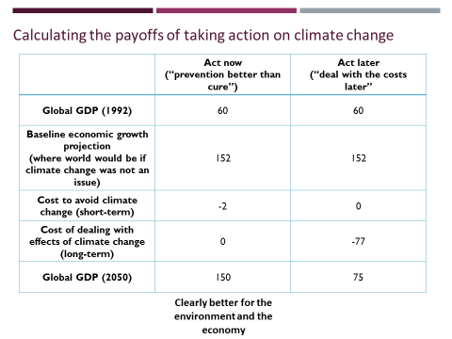

**Four scenarios for negotiations between rich and poor countries**

While the social optimum is clear, when you apply a game theory analysis, you begin to see that the incentives between competitors lead to an equilibrium that is not the social optimum. The driver of this is that if the majority of countries are coordinating to fix climate change, there are incentives for individual countries to cheat or defect. That way they don’t pay the short-term costs of avoiding climate change (by delaying action until later) but also don’t have the risk of long-term costs of climate change (since other people are acting now).

The decision at the negotiations table for both Rich and Poor countries is whether they act now (before climate change) or act later (wait for climate change to happen and then act).

The 4-box matrix below shows the four potential scenarios that could have come out of the mid-1990s climate change negotiations:

1. Green growth – all countries act now, no change in global distribution of wealth
2. Green equity – rich act first, poor act later, most of climate change is avoided (since rich countries have the majority of emissions) but poor countries are able to catch-up on global development
3. Carbon colonialism – poor countries act now, rich act later. Much of climate change still occurs and rich get richer.
4. Carbon wasteland – no countries act until later. Catastrophic climate change occurs, world economy suffers, no change in distribution of wealth.

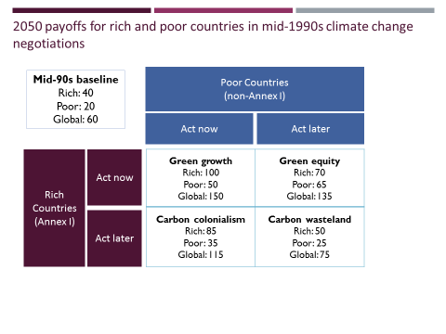

**Understanding game theory equilibrium**

The equilibrium outcome for the game is the Green Equity scenario. Below we illustrate the dynamics of the game that lead to this finding.

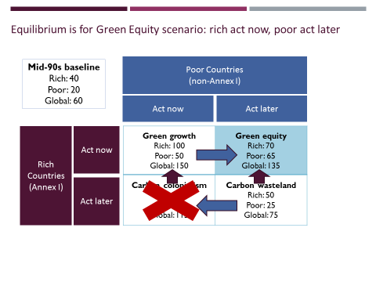

*Dominant strategy for rich countries: act now*

Regardless of what poor countries do, rich countries profit from acting now. If they don’t, drastic climate change will occur and they will harm their economic outcomes. They therefore have a dominant strategy to act now.

This is in fact what happened. Developed countries agreed to take on carbon constraints even without developing country action.

*Poor countries will push for green equity*

Given that rich countries are going to act now, poor countries profit by pushing for green equity. Rich countries will avoid drastic climate change by acting and poor countries get the chance to catch up in economic growth.

This is in fact what happened.

At the first UNFCCC Conference of the Parties in Berlin, the G77 was able to push for a mandate (the "Berlin mandate") where it was recognized that:[67]

* developed nations had contributed most to the then-current concentrations of GHGs in the atmosphere.
* developing country emissions per-capita (i.e., average emissions per head of population)[68] were still relatively low.
* and that the share of global emissions from developing countries would grow to meet their development needs.

The Berlin mandate was recognized in the Kyoto Protocol in that developing countries were not subject to emission reduction commitments in the first Kyoto commitment period.[67] However, the large potential for growth in developing country emissions made negotiations on this issue tense.

Finally, we also note that carbon colonialism is not a viable option given the fact that poor countries such as China and India are powerful nuclear forces and would not accept this outcome without a fight (possibly military).

**Changing the game: the Clean Development Mechanism (CDM)**

In an attempt to encourage poor countries to act earlier, parties attempted to change the game by introducing the Clean Development Mechanism (CDM). Under this mechanism rich countries would be able to meet some of their Kyoto carbon obligations by funding clean development in poor countries.

This gave rich countries cheaper compliance. It also meant the poor countries would be able to start moving to a low-carbon economy now. It was hoped that by the time that the negotiation of the second round of obligations under Kyoto came (for 2012-2020), poor countries would be on a low-carbon growth pathway and therefore be willing to take on a carbon constraint target.

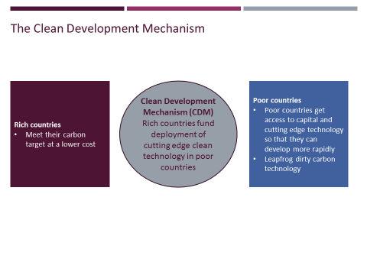

The graphic below shows how this transfer of money from rich to poor countries through the CDM hoped to change the payoffs in the game and push the outcome to something more like the social optimum of green growth.

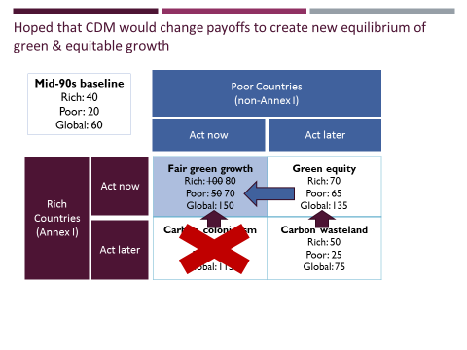

**Breakdown of Kyoto agreement**

The Kyoto Protocol had been intended to be a long-term agreement that would govern the carbon constraints for countries around the world in the effort to avoid devastating climate change. While only Annex I countries took on targets in the first commitment period of 2008-2012, it was envisaged that developing countries would take on binding targets in the second commitment period (2012-2020) and that all countries would take on additional stricter targets in subsequent commitment periods.

While a second commitment period was proposed in 2012, with Europe signaling that it would commit to 20% cuts in emissions by 2020, withdrawal of support from non-European industrialized countries and developing countries has led to the breakdown of the Kyoto Protocol. The focus of climate negotiations has now moved on to the designing an alternative regime for achieving reductions in emissions.

**US withdraws support for Kyoto**

The USA had been a driving force behind the UNFCCC and the Kyoto Protocol. However, in 2001, President Bush announced the US would not ratify the agreement.

Bush said that while he took climate change "very seriously,” he opposed Kyoto because "it exempts 80% of the world, including major population centers such as China and India, from compliance, and would cause serious harm to the US economy."[1]

But this was the very structure that the US had negotiated in the first place. Why the change in US policy?

We believe three four factors came into play:

1. **Economic downturn.** The bursting of the dotcom bubble and the subsequent recession focused US electorate on short-term issues such as unemployment and protecting US jobs from being outsourced to cheaper countries. As shown in the chart from Gallup below when unemployment rises, political support for climate action erodes.

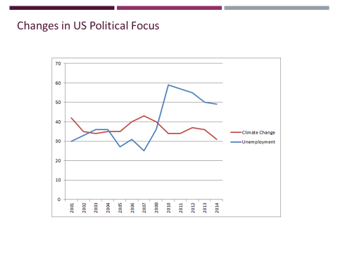

1. **Rapid rise of China**. China’s growth during the late 1990’s and early 2000s was rapid. Projections had started to note that China would overtake the US as the largest economy in the world. There was an increasing concern that the US should be working to limit Chinese power and ensure US supremacy in geopolitics. The idea of the US providing money and technology to China while restricting its own ability to grow through a carbon constraint seemed counter to this objective. The US would prefer to keep these as bargaining chips in the broader negotiation agenda with China over coming years.

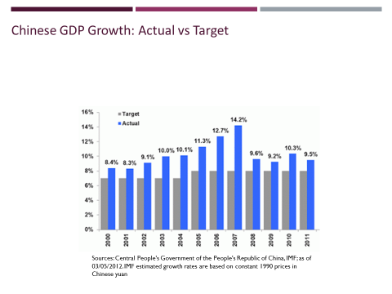

1. **Alliance of Bush with US fossil fuel interests.** Bush had worked for the US oil industry and received significant financial support from the industry on his road to the White House. It was speculated that this directly influenced his decision to remove support from Kyoto which essentially aims to reduce fossil fuel use around the world.
2. **US did not believe it could achieve Kyoto target.** The US had struggled to achieve progress towards reaching its Kyoto target with voluntary measure and many US politicians may have been unwilling to pursue the politically unpopular routes of forcing further cuts to emissions.

As the US accounted for 36% of emissions in 1990, the withdrawal of the US meant that the Kyoto Protocol could only come into force if the EU, Russia, Japan and a coalition of other small parties ratified the treaty.

**Australia follows the US lead and withdraws support for Kyoto**

Australia followed the US lead. In the immediate aftermath of Bush’s announcement most countries were criticized the US position and attempted to lobby for their continued support of the Kyoto Protocol. However, Australia’s Prime Minister John Howard offered a sympathetic response:

“What President Bush is concerned about and it is an understandable concern is you can't have a comprehensive agreement unless you get the developing countries inside the tent. That's his argument. That doesn't mean to say we shouldn't all continue to try to get the comprehensive agreement.”[2]

One year later, Howard stated Australia would adopt the same policy as the US and only ratify Kyoto once all emitters – in particular China, India and Indonesia – came under the agreement:

"For us to ratify the protocol would cost us jobs and damage our industry"[3]

The key industry of concern for Australia was coal exports. Australia’s mining industry is a major component of the country’s GDP and is the largest component of Australian exports. Australia has some of the largest coal reserves in the world (over 500 years of estimated reserves) and exports both steam and metallurgical coal to nations around the world. Prime Minister Howard noted his specific concern saying “Australia was a net exporter of energy and ratification would mean the loss of important markets to non-signatory countries such as Indonesia.”[4]

It was also speculated that Australia’s decision was directed to maintaining a strong and broad alliance with the US. What can definitely be said is that Australia would never have removed support for the Protocol if the US had continued to support it.

**Other developed countries ratify – bringing Kyoto into force**

While Australia and the US withdrew support for the Kyoto Protocol, the remaining developed countries did end up supporting the Protocol. The three most important parties that led this coalition were the EU bloc, Japan and Russia.

*EU and Japan*

In addition to the moral obligation to act on climate change, the EU and Japan had a significant additional incentive to support the Kyoto Protocol – they saw the carbon constrained world as a game that they could win. There were three reasons for this:

1. Having limited fossil fuel interests meant they were large net fossil fuel importers. Switching to non-fossil fuels would improve their energy security and trade balances
2. EU and Japan were both leaders in the development of clean energy sources – they believed they could capture economic growth related to the world shifting to cleantech
3. They believed they could reach their Kyoto targets. The EU had plenty of room to make its Kyoto target due to the fact that it had absorbed former Eastern bloc countries into its membership (each of which had greatly reduced emissions since 1990 due to the mothballing of outdated Soviet facilities)

These countries had a big incentive to lead the world into a low carbon future.

*Russia*

Russia ratified Kyoto in 2004. In so doing it brought Kyoto into force. At first glance Russia’s ratification seems against their interests – the country has huge fossil fuel reserves and exports. Kyoto would therefore seem to be against their economic interests. Two reasons seem to have led to Russia offering its support to the Protocol:

1. Russia wanted the EU to support its bid to enter the WTO. Russia had been trying for ten years to gain entry into the WTO. It is speculated that support for Kyoto was one of the requirements for the EU offering support for Russia’s WTO entry.
2. In the short-term, Russia stood to gain significant financial inflows from the Kyoto Protocol due to the fact that – as with all former Eastern bloc countries – it had such a generous over-supply of Kyoto carbon credits that it would be able to sell to countries that could not meet their carbon targets.

**Australia ratifies in 2007**

With the winds of change behind Kyoto protocol, the US and Australia stood alone as countries that had pulled out. Social pressure and the threat that continued defection would mean missing out on the opportunities of the global transition to low-carbon economy led to Australia having a major political debate about Kyoto from 2005 (when it came into force) to 2007 (the next Federal election). Ratification of Kyoto was a key election promise of Kevin Rudd – and arguably a key part to his ousting of John Howard from power. Upon taking office, Kevin Rudd announced Australia would ratify Kyoto.

"This is the first official act of the new Australian Government, demonstrating my Government's commitment to tackling climate change," Mr Rudd said in a statement.

This points to the fact that individual countries face significant social pressure and economic penalties for continuing to defect when all other countries are coordinating.

**Failure to adopt further targets at Copenhagen**

At the Copenhagen climate conference in 2009, countries failed to agree on the second round of binding carbon constraints.

The main tension was that developing countries were unwilling to take on carbon constraints. This was a reversal against what had been envisaged in the climate negotiations of the mid-90s.

The main reason why developing countries did not want to take on carbon constraints was that they had not successfully transitioned to a low carbon growth path. The Kyoto Protocol had only minor impacts. It did not leave developing countries with a clean and green infrastructure that would allow them to decouple economic growth from carbon emissions. Economic growth remains highly carbon intensive.

**Carbon dioxide emissions due to consumption in China**Source: US Energy Information Administration

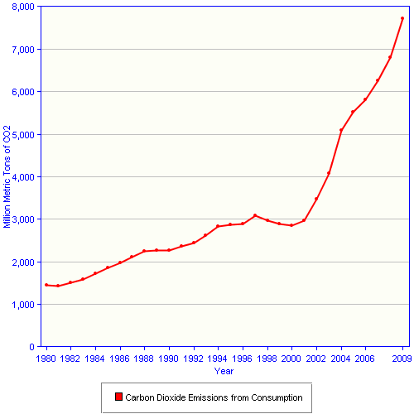

As a result, they still felt it was unjust for them to take on carbon constraints particularly since on a per capita basis, developed countries still far outweighed developing countries (See below).

**Per capita CO2 production and consumption, 1995 and 2009**Source: http://www.oecd.org/industry/ind/carbondioxideemissionsembodiedininternationaltrade.htm

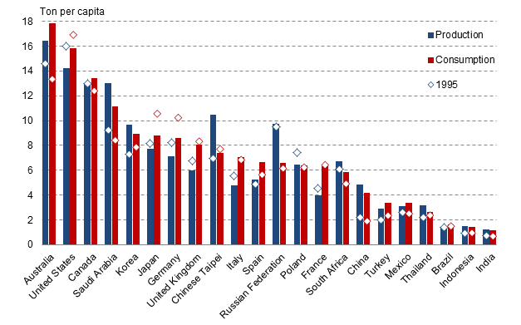

**End of Kyoto**

With the failure to get developing countries to agree to targets, all major developed countries except for Europe withdrew support for further unilateral action by developed countries on embracing targets.

Japan, Russia and Canada announced they would not take on further targets until a broader agreement was reached. In 2011 Canada withdrew from the Kyoto Protocol altogether – having breached its Kyoto target by more than 20%, it feared having the pay financial penalties. This points to a key weakness in international legal agreements – they are very difficult to enforce.

The lesson – once coordination breaks down, more countries will begin defecting. The exception to this has been Europe – they have continued to lead on climate change commitments offering a 20% reduction of emissions by 2020. Europe is doubling down on a carbon constrained world, a world that they may want to see for reasons of energy security irrespective of the broader issue of avoiding climate change. This has been thrown into sharp relief by the use by Russia of natural gas supply as a weapon against Europe.

**Where are we now**

The world ended up halfway between the Green Growth and Green Equity scenarios. Significant action was taken by developed countries on emissions, even the US. On average rich countries me the Kyoto targets (see appendix), but largely due to the economic recession in 2007-2009.

Developing countries have also taken some action on climate change. Although they have not agreed to carbon targets, there has been significant unilateral investment by these countries in cleantech. China is now the largest investor in cleantech in the world. The main reason for this is that they are feeling the direct pain of local air pollution. They also know that a carbon constrained world is the inevitable future and need to prepare their economies for that eventuality.

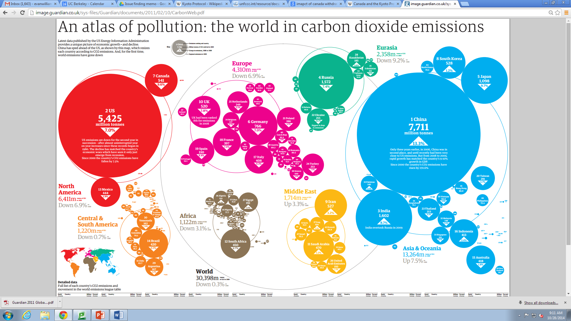

**Lessons from the breakdown**

We would like to make five observations on the breakdown of climate negotiations:

1. **Irrationality of domestic political consensus.** Our analysis of the payoffs in the climate negotiations game is based on an assumption of rationality. A rational person would follow the payoffs outlined in the game. However, the US and Australia’s defection can in part be seen as resulting from a loss of political will.Countries are not rational machines, but rather bodies politic. And politics is rarely a purely rational thing.
2. **Short-term vs long-term.** Even when the relative payoffs are clear, it is hard to convince people to make short-term sacrifices for long-term gains. This is particularly true when the long-term is likely beyond the lives of many of the short-term decision-makers. A rational decision in this timeframe depends on an ethical and selfless approach of asking what is rational for the world and the future world. That is a very different type of rationality compared to how we normally understand it in economic analysis.
3. **The multi-dimensional nature of international negotiations**. Carbon is only one piece on a broader chessboard of geopolitics. US withdrawal from Kyoto was in part driven by concerns about the rising power of China and the need for additional leverage in that interaction. Russia’s support for Kyoto was largely driven by their desire to get access to the WTO. These incentives can overwhelm any payoffs in the narrow analysis of climate change negotiations alone.
4. **The difficulties of mechanism design in international law**. Canada pulled out of Kyoto because it knew it feared financial penalties and it was allowed to pull out. Without coordination, social pressure and the threat of future lack of assistance and cooperation, there is little the international community can do to enforce behavior on sovereign nations.
5. **The role of scientific uncertainty in climate change negotiations.** Climate science is very complicated. Throughout the climate change negotiations, scientists have been racing to understand more about the global climate system, how human-generated carbon emissions affect that system and the environmental and economic impacts that will result from changes in the climate. In the mid-1990s, the significant scientific uncertainty was explicitly recognized by parties to the climate negotiations. However, they dealt with this by embracing the “precautionary principle” – due to the potentially catastrophic effects of climate change, countries should take the relatively low cost actions required to avoid climate change now, even though they did not have full scientific certainty. The existence of uncertainty has been used by opponents of carbon constraints to break down political support for climate action. Even now that we have much greater certainty about the fact that humans are causing climate change and that climate change will be catastrophic, opponents of climate action have been able to target scientific uncertainty as a reason to block action in countries such as Canada, Australia and the US.

**Conclusion**

Negotiations are currently under way to agree on a post-Kyoto legal framework that would obligate all major polluters to pay for CO2 emissions. China, India, and the United States have all signaled that they will not ratify any treaty that will commit them legally to reduce CO2 emissions. The new framework will be negotiated at the December 2015 meeting of the Conference of Parties to the UNFCCC in Paris, France.

We propose to use game theory to analyze this next phase of negotiations in our final paper for the semester.

**Appendix**

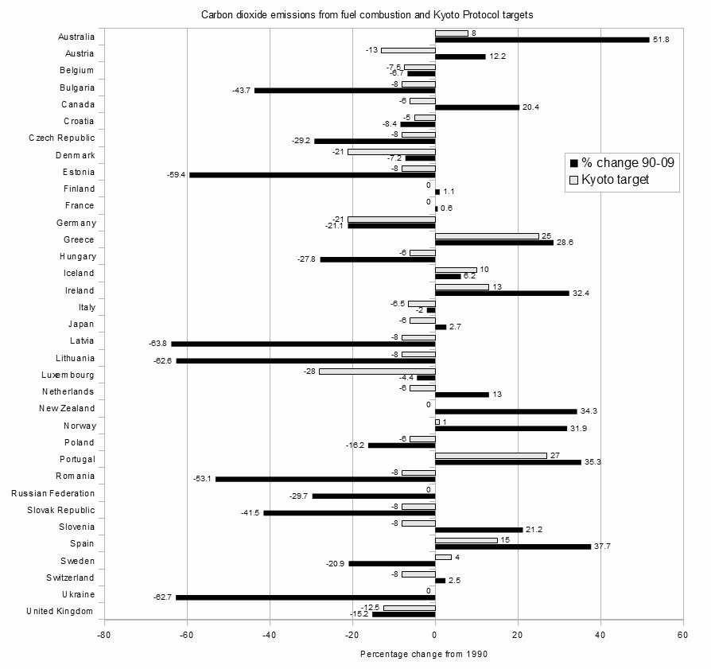

1. http://georgewbush-whitehouse.archives.gov/news/releases/2001/03/20010314.html
2. http://www.abc.net.au/7.30/stories/s270661.htm
3. http://news.bbc.co.uk/2/hi/asia-pacific/2026446.stm
4. http://www.theage.com.au/articles/2002/09/04/1031115885007.html