Recommended Additional Reading in Marketing
If you click on the picture of each book’s cover, it’s hyperlinked to Amazon

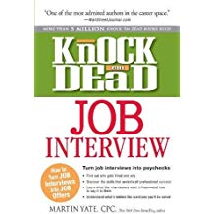 | Knock ‘am Dead, Martin Yate | Not a Marketing book, but the essential interview prep book. (Martin Yate also has books on Resume Writing, so make sure you use this one.) It’s cheap! <$11 USD on Amazon. It coaches you on how to handle those predictable “What is your biggest weakness?” awful questions.
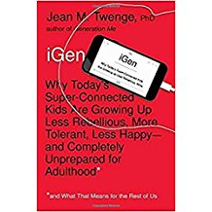 | iGen, Jean Twenge | Dr. Twenge writes very well. This book explains how the cohort after “the Millennials” is different – they’ve never known a time without a smart phone in their hands. A great Consumer Behavior read.
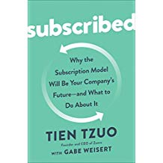 | Subscribed, Tien Tzuo | This is the hit business book of the summer. Like most popular books, the thesis is over-played – it implies that all businesses will go to a simple monthly-subscription model.  However, it’s useful in documenting the consumer preference for /usership/ rather than /ownership/.
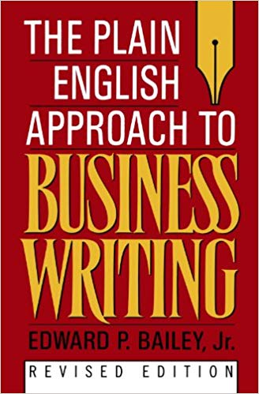 | The Plain English Approach to Business Writing, Edward Bailey | This is the book I wish I’d written! It shows you how to write simply and clearly and that “Plain English” is not unsophisticated.
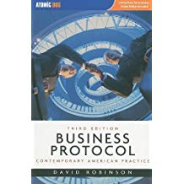 | Business Protocol, 3rd Edition, David Robinson | This is the textbook I wrote for Haas students. It assumes you know how to write and goes on to the “how to” and cultural norms of American business, such as what to do when you’re invited for a barbecue at the boss’s house.
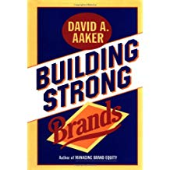 | Building Strong Brands, David Aaker | Prof. Aaker was my predecessor at Haas, now retired. This book is, what? Twenty years old now, but it has some good stories from successful firms.
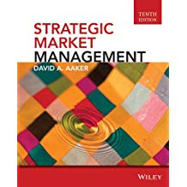 | Strategic Market Management, David Aaker | This is the text we use for the next course, Marketing Strategy. It’s not an easy read, but it has great checklists for when you are at work in Marketing. The current edition (11th) is absurdly expensive (textbook) but you can benefit from 11th or 10th ed bought cheaply second-hand
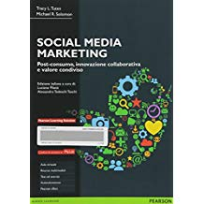 | Social Media Marketing, Tuan and Solomon | This is a textbook and is expensive. I’ve read it and found it to be comprehensive and useful. It classifies different types of social media and introduced me to the concept of “social publishing”.
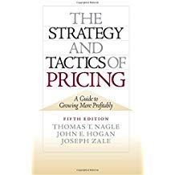 | The Strategy and Tactics of Pricing, Nagle, Hogan & Zale | This is the standard text on pricing.
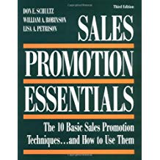 | Sales Promotion Essentials, Schultz, Robinson and Petrison | Sadly, the second author isn’t me – for this is a beautiful written book that tells you when to discount by 50 cents or when to add 2 oz. more free.
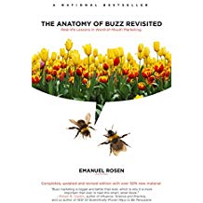 | The Anatomy of Buzz Revisited, Emanuel Rosen | A definitive book on how to drive word of mouth.
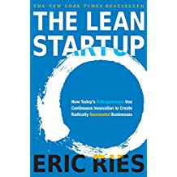 | The Lean Startup, Eric Ries | The best seller on the Silicon Valley style of entrepreneurship.
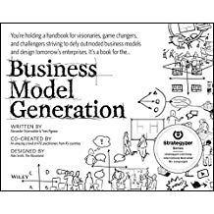 | Business Model Generation, Osterwalder & Pigneur | I refer to this book in all my courses. It shows that there are many different ways to organize a business, even when firms are going after the same customers.
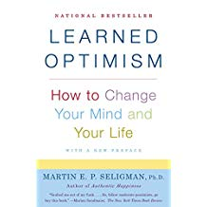 | Learned Optimism, Martin Seligman | Not a business book, but an important read if you get turned down for your first choice of grad school or work.
 | Games People Play, Eric Berne | Ignore the theory of Transactional Analysis, but read this to be able to recognize familiar patterns of interaction by co-workers, such as the one who always fails to complete projects and indulges in exaggerated apologies.

